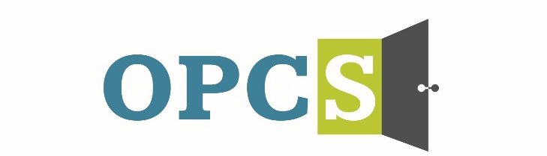
Southern Arizona’s Premier Social Service Agency

Old Pueblo Community Services is an EOE/M/F/VET/DISABILITY Employer
Shelter Monitor I  Must be available to work a flexible schedule  The Shelter Monitor I is responsible for providing a safe, welcoming, and well-maintained environment for clients and staff. The role involves interacting with individuals who are experiencing homelessness, Serious Mental Illness, Substance Use Disorder, and other related conditions. This role may involve flexible hours, including nights, weekends, and holidays.  Employee Benefits  Competitive Salary, Employer Subsidized Health Insurance for Employee and Family, Employer Matching 401 (k) plan (after 1 year), Employer Subsidized Dental Plan and Vision Plan, Paid life insurance, Employer Paid Training, 136 Hours Paid Time Off (PTO) Per Year.  Duties and Responsibilities:  - Conduct daily Health and Safety Inspections of the property.  - Complete wellness checks with clients.  - Provide hospitality services to client as needed.  - Conduct new client orientations.  - Monitor the property at regularly scheduled intervals.  - Document and report observations of client’s behaviors, activities, and demeanors.  - Provide crisis intervention utilizing the Crisis Prevention Institute (CPI) model and contact emergency services as needed.  - Complete minor maintenance repairs as needed.  - Clean vacant units as needed.  - Assist with facility laundry needs.  - Other duties as assigned.  Qualifications:  - Possess and maintain valid CPR/First Aid Certification, or ability to attend training and pass certification.  - Responsible and dependable, committed to a team approach.  - Basic computer skills (e.g., email, navigate website, complete web forms)  - Willingness to learn and practice evidence-based practices, such as De-escalation (CPI Model), Motivational Interviewing, Housing First and Harm Reduction.  Preferred Qualifications:  - Bilingual |  |   Employment References, background check is conducted pre-employment.
  Job Status
  Full Time
  Pay Rate
  $15.45 - $16.95 - $18.90
  Pay Comments
  Salary based on experience.
  In accordance with pay transparency, the salary reflected in this posting is the full salary range for this position. Individual placement within the range is based on the candidate’s current experience, education, skills, and abilities related to the position. Salary placement is typically between the minimum and mid-point of the salary range.
  We are willing to train those who are passionate about helping people and willing to go the extra mile to help the client.
  Old Pueblo Community Services
  2323 S. Park Ave
  Tucson, AZ 85713

