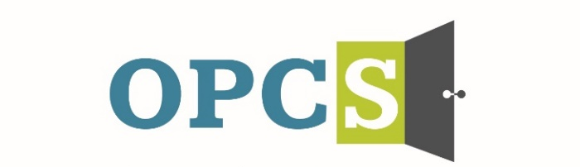
Southern Arizona’s Premier Social Service Agency

Old Pueblo Community Services is an EOE/M/F/VET/DISABILITY Employer
Peer Recovery Support Specialist  Monday-Friday 5:00pm – 12:00am  Peer Recovery Support Specialist will provide services to support client in the IOP program. Duties may include providing individual and group peer support services to clients.  Employee Benefits  Competitive Salary, Employer Subsidized Health Insurance for Employee and Family, Employer Matching 401 (k) plan (after 1 year), Employer Subsidized Dental Plan and Vision Plan, Paid life insurance, Employer Paid Training, 136 Hours Paid Time Off (PTO) Per Year.  Selected by the Tucson Metro Chamber of Commerce as the best non-profit for Workforce Development in 2019, and Outstanding Non-profit in 2014.  Duties and Responsibilities:  - Deliver peer recovery support services including individual and group services.  - Utilize experiential knowledge through supportive story telling.  - Document services and information within the CT1 electronic health record.  - Meet billable expectations as set by OPCS.  - Communicate with program staff daily to report general observation of residents’ wellbeing to include any events or concerns that clients may be involved in.  - Complete incident reports as needed.  - Maintain client records and information in a confidential manner and in compliance with grant, OPCS, and HIPAA standards.  - Attend all mandatory trainings.  - May transport clients.  - Other duties as assigned.  Qualifications:  High School Diploma or GED. Must obtain and maintain valid CPR/First Aid certification. Credentialed as a PRSS by completing training through PSETP and passing the competency exam. Certification may be obtained within 6 months of hire. Minimum of six weeks of behavioral health work experience and preference of one year experience. Self-identify as an individual who: Is or has been a recipient of behavioral health treatment for mental health disorders, substance use disorders, and/or other traumas associated with significant life disruption and has an experience of recovery to share. Ability to learn and use evidenced based practices such as Motivational Interviewing, familiarity with Housing First, Harm Reduction, and Trauma Informed principles. Ability and willingness to work flexible schedules. Cultural competence of diverse populations. Bilingual, bicultural and/or Veteran a plus. Valid Arizona driver’s license, proof of auto insurance and reliable transportation. |  |   Employment References and background check are conducted pre-employment.
  Job Status
  Full Time
  Pay Rate
  $16.24 - $19.44 - $22.65
  Pay Comments
  Salary based on experience.
  In accordance with pay transparency, the salary reflected in this posting is the full salary range for this position. Individual placement within the range is based on the candidate’s current experience, education, skills, and abilities related to the position. Salary placement is typically between the minimum and mid-point of the salary range.
  We are willing to train those who are passionate about helping people and willing to go the extra mile to help the client.
  Old Pueblo Community Services
  2323 S. Park Avenue
  Tucson, AZ 85713

