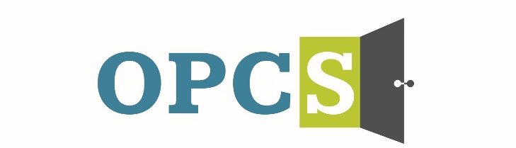
Southern Arizona’s Premier Social Service Agency

Old Pueblo Community Services is an Equal Opportunity Employer
Case Manager II  STAR – Women’s safe outdoor space  Monday – Friday 8:00am – 5:00pm  Case Manager II is responsible for the engagement, assessment, support, and coordination of care for individuals who have experienced homelessness. The role involves interacting with individuals who are experiencing homelessness, Serious Mental Illness, Substance Use Disorder, and other related conditions.  Employee Benefits  Competitive Salary, Employer Subsidized Health Insurance for Employee and Family, Employer Matching 401 (k) plan (after 1 year), Employer Subsidized Dental Plan and Vision Plan, paid life insurance, Employer Paid Training, 136 Hours Paid Time Off (PTO) Per Year  Duties and Responsibilities:  - Complete the intake process, relapse prevention plan, Behavioral Health Assessment, and Recovery Plan for high acuity clients or programs.  - Deliver services in alignment with the client’s recovery plan to assist and support clients in reaching identified goals.  - Complete the Colombia Suicide Severity Rating Scale (C-SSRS) and plan for individuals who are moderate and high risk.  - Update the Recovery Plan as services are completed.  - Connect clients to mainstream services and other service organizations as needed.  - Facilitate Adult Recovery Team (ART) meetings.  - Provide case management and life skills individual and/or group sessions.  - Document services and information within the Electronic Health Record (EHR).  - Maintain all client files in a confidential manner and in compliance with HIPAA standards.  - Monitor clients’ compliance with program guidelines and provide appropriate guidance to those clients who are out of compliance.  - Work closely with OPCS team, collaborators and other members of client’s support team, including Home Health Care agencies, parole and probation offices.  - Assist with coaching and training of Case Manager I staff.  - Other duties as assigned.  Qualifications:  - Must meet one of the following education and experience requirements:  - Master’s degree or bachelor’s degree in a field related to behavioral health.  - Bachelor's degree (in any field) and at least one year of full-time behavioral health work experience  - Associate's degree and at least two years of full-time behavioral health work experience.  - High school diploma or high school equivalency diploma with at least four years of full-time behavioral health work experience.  - Demonstrated competency in Evidenced-Based Practices including:  - Housing First  - Harm Reduction  - Motivational Interviewing  - De-escalation (CPI Model)  - Possess and maintain valid CPR/First Aid Certification, or ability to complete training and pass certification.  - Knowledge of resources in the community.  - Strong communication and interpersonal skills.  - Strong computer skills (e.g., Microsoft Word, Outlook, Excel).  - Self-starter committed to a team approach, responsible, dependable, ability to set priorities, meet deadlines and work flexible hours.  - Valid Arizona driver’s license, proof of auto insurance and reliable transportation.  Preferred Qualifications:  - One year of experience working with the unsheltered population.  - Experience using an Electronic Health Record (EHR).  - Bilingual |  |   Employment References, background check are conducted pre-employment.
  Job Status
  Full Time
  Pay Rate
  $18.88 - $23.10 - $27.32
  Pay Comments
  Salary based on experience.
  In accordance with pay transparency, the salary reflected in this posting is the full salary range for this position. Individual placement within the range is based on the candidate’s current experience, education, skills, and abilities related to the position. Salary placement is typically between the minimum and mid-point of the salary range.
  We are willing to train those who are passionate about helping people and willing to go the extra mile to help the client.
  Old Pueblo Community Services
  2323 S. Park Ave
  Tucson, AZ 85713

