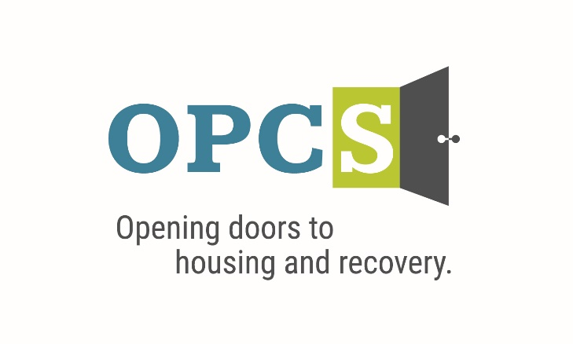

***Southern Arizona’s Premier Social Service Agency***

*Old Pueblo Community Services is an Equal Opportunity Employer*

|  |  |  |  |  |  |  |  |
| --- | --- | --- | --- | --- | --- | --- | --- |
| **IOP Clinical Supervisor**  Are you a compassionate and empathetic leader with a commitment to integrity and quality in clinical care? We are seeking a Substance Use IOP Clinical Supervisor who values choice, optimism, and leadership in supporting clients on their path to recovery.  As the Clinical Supervisor, you will oversee the OPCS substance use IOP treatment services, ensuring that participants, referred from multiple entities including ADOC and community providers, receive the highest standard of care. Many participants live on OPCS housing property and face complex challenges, including homelessness. Your role will be crucial in providing clinical oversight to staff and services within the substance use IOP.  **Employee Benefits**  Competitive Salary, Employer Subsidized Health Insurance for Employee ***and Family***, Employer Matching 401 (k) plan (after 1 year), Employer Subsidized Dental Plan and Vision Plan, Paid life insurance, Employer Paid Training, 160 Hours Paid Time Off (PTO) Per Year.  ***Selected by the Tucson Metro Chamber of Commerce as the best non-profit for Workforce Development in 2019, and Outstanding Non-profit in 2014.***  **Duties and Responsibilities:**   1. Oversee and implement the OPCS substance use IOP program with a focus on empathy, compassion, and quality. 2. Supervise and ensure the intensity and level of services align with clients’ recovery plans, meeting their unique needs with integrity. 3. Ensure that assigned staff meet required competencies in all aspects of their job duties, fostering a culture of continuous improvement and excellence. 4. Provide effective coaching and supervision to staff, embodying optimism and leadership. 5. Manage budget, grant implementation, and deliverables with precision and accountability. 6. Review and sign off on clinical documentation from program staff (e.g., BHAs, recovery plans, progress notes, suicide assessments). 7. Perform other duties as assigned, demonstrating flexibility and entrepreneurial spirit.   **Qualifications:**  Must be independently licensed by the Arizona Board of Behavioral Health Examiners. Master’s degree in counseling, social work, substance use, or related field. Demonstrated leadership experience in behavioral health, with a strong emphasis on empathy and compassion. Outstanding written and oral communication skills. Highly organized, creative, flexible, and able to manage multiple tasks efficiently. Exceptional interpersonal skills; ability to be leader and a team player. Strong computer skills. Possess and maintain valid CPR/First Aid Certification.  Join us in making a meaningful difference in the lives of those we serve, through a commitment to quality, choice, and integrity. Apply today to become a pivotal part of our compassionate and optimistic team. |  | |  | | --- | | Job Status Full Time | |  | | Pay Rate $60,694 - $74,838 - $88,961 | | **In accordance with pay transparency, the salary reflected in this posting is the full salary range for this position. Individual placement within the range is based on the candidate’s current experience, education, skills, and abilities related to the position. Salary placement is typically between the minimum and mid-point of the salary range**  **Pay Comments Salary based on experience**.  ***We are willing to train those who are passionate about helping people and willing to go the extra mile to help the client.*** |   Mail Resume/Application to:   |  | | --- | | Ms. Jeanie Pike  HR Director  Old Pueblo Community Services  2323 S. Park Ave. Tucson, AZ 85713 |   Email Resume/Application to:  [**hr@helptucson.org**](mailto:hr@helptucson.org)  http://bantheboxcampaign.org/wp-content/uploads/2013/01/ban-the-box.jpg  Employment References background check is conducted pre-employment. |