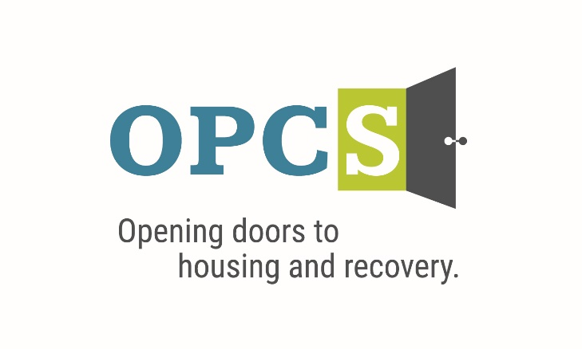

***Southern Arizona’s Premier Social Service Agency***

Old Pueblo Community Services is an EOE/M/F/VET/DISABILITY Employer

|  |  |  |  |  |  |  |  |
| --- | --- | --- | --- | --- | --- | --- | --- |
| **Accountant**  **Work schedule: Monday - Friday 8:00am - 5:00pm**  Under the direction of the Director of Finance, this position will be responsible for accounting functions with the Finance department, including cash management, accounts payable processing, review of staff data entry, and other duties as assigned.  **Employee Benefits**  Competitive Salary, Employer Subsidized Health Insurance for Employee ***and Family***, Employer Matching 401 (k) plan (after 1 year), Employer Subsidized Dental Plan and Vision Plan, Paid life insurance, Employer Paid Training, 160 Hours Paid Time Off (PTO) Per Year.  ***Selected by the Tucson Metro Chamber of Commerce as the best non-profit for Workforce Development in 2019, and Outstanding Non-profit in 2014.***  **Duties and Responsibilities:**   1. Update weekly cash forecast for executive decision-making. 2. Performs monthly balance sheet reconciliations. 3. Aids in the annual audit and budgeting processes. 4. Records various journal entries and financial transactions. 5. Codes and inputs accounts payable request and credit card transactions. 6. Posts daily cash receipts. 7. Prepares property and insurance allocations. 8. Assists with review of grant billings and grant budget creation. 9. Maintains agency vehicle mileage logs. 10. Responsible for oversight of petty cash funds. 11. Opens physical mail with Finance staff and verifies logged information. 12. Contributes to team effort by accomplishing results as needed. 13. Other duties as assigned.   **Qualifications:**  Bachelor’s degree in accounting with a minimum of 2 years of experience in a professional Accountant role. Non-profit experience preferred. Proficiency with Adobe Acrobat Pro and Microsoft Office software with emphasis on Excel, Word, and Outlook. Experience with Accounting software preferred. Strong attention to detail, organizational, time-management, and prioritization skills. Excellent communications skills, both verbal and written, to deal with customers (internal and external) at all levels. Personal vehicle for use on agency business, with proof of insurance.  Able to create and navigate spreadsheets in Excel with ease. Strong attention to detail, communication, and problem-solving skills, Enthusiastic and accountable to quickly take on tasks and reliable to complete assigned tasks independently after training period. Strong understanding of debits, credit, payable processing, accruals, and other accounting functions. |  | |  | | --- | | **Job Status** Full Time | |  | | **Pay Rate**  **$50,876 - $62,566 - $74,235** | | Pay Comments Salary based on experience.  In accordance with pay transparency, the salary reflected in this posting is the full salary range for this position. Individual placement within the range is based on the candidate’s current experience, education, skills, and abilities related to the position. Salary placement is typically between the minimum and mid-point of the salary range.  **We are willing to train those who are passionate about helping people and willing to go the extra mile to help the client.** |  |  | | --- | | Old Pueblo Community Services  2323 S. Park Ave  Tucson, AZ 85713 |   Email Resume/Application to:  **hr@helptucson.org**  http://bantheboxcampaign.org/wp-content/uploads/2013/01/ban-the-box.jpg  Employment References background check is conducted pre-employment. |