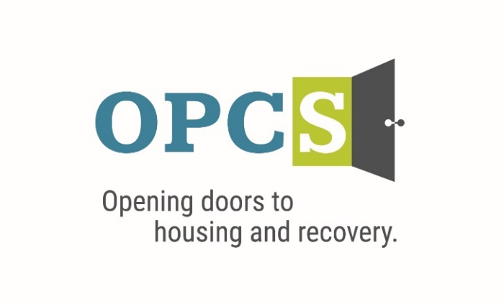
Southern Arizona’s Premier Social Service Agency

Old Pueblo Community Services is an EOE/M/F/VET/DISABILITY Employer
Peer Recovery Support Specialist  “Safety Sensitive Job”  A Safety sensitive position is a job or position where the employee holding this position has the responsibility for his/her own safety or other people’s safety. An employee has to be with clear mind and diligent while occupying such position.  The Peer Recovery Support Specialist helps the case manager to navigate clients into the housing program and other mainstream resources. PRSS assists clients in receiving the services needed and helps the client connect with those services. The PRSS also assists the supportive housing manager with day-to-day tasks related to program administration.  Employee Benefits  Competitive Salary, Employer Subsidized Health Insurance for Employee and Family, Employer Matching 401 (k) plan (after 1 year), Employer Subsidized Dental Plan and Vision Plan, Paid life insurance, Employer Paid Training, 136 Hours Paid Time Off (PTO) Per Year.  Selected by the Tucson Metro Chamber of Commerce as the best non-profit for Workforce Development in 2019, and Outstanding Non-profit in 2014.  Duties and Responsibilities:  - Conducts recruitment/outreach and follow-up activities to unsheltered homeless individuals under the direction of the Supportive Housing Manager.  - Deliver peer recovery support services to both unsheltered and housed clients.  - Utilize experiential knowledge through supportive story telling.  - Document services and information within the CT1 electronic health record.  - Document services and information within the HMIS record.  - Meet billable expectations as set by OPCS.  - Complete incident reports as needed.  - Maintain client records and information in a confidential manner and in compliance with grant, OPCS, and HIPAA standards.  - Attend all mandatory training.  - Transport clients.  - Other duties as assigned.  Qualifications:  High School Diploma or GED. Must possess and maintain valid CPR/First Aid certification. Must possess and maintain a valid Arizona Driver’s License, Automobile Insurance, and a car. Completion of the State approved PRSS Academy. Minimum of six weeks of behavioral health work experience and preference of one year experience. Recent outreach experience with unsheltered homeless individuals in the geographical area. Ability and willingness to work flexible schedules. Cultural Competence of diverse populations. Bilingual, Bicultural and/or Veteran a plus. |  | Job Status  Full Time  Pay Rate  $16.24 - $19.44 - $22.65  Pay Comments  Salary based on experience.  In accordance with pay transparency, the salary reflected in this posting is the full salary range for this position. Individual placement within the range is based on the candidate’s current experience, education, skills, and abilities related to the position. Salary placement is typically between the minimum and mid-point of the salary range.  We are willing to train those who are passionate about helping people and willing to go the extra mile to help the client.  Mail Resume/Application to:  Ms. Jeanie Pike  HR Director  Old Pueblo Community Services  2323 S. Park Avenue  Tucson, AZ 85713  Email Resume/Application to:  hr@helptucson.org    Employment References, drug screen and background check are conducted pre-employment.

