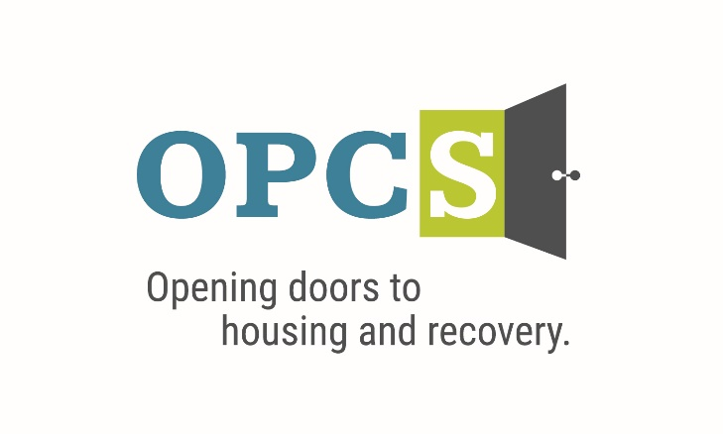

***Southern Arizona’s Premier Social Service Agency***

Old Pueblo Community Services is an EOE/M/F/VET/DISABILITY Employer

|  |  |  |  |  |  |  |  |
| --- | --- | --- | --- | --- | --- | --- | --- |
| **Young Adult Care Coordinator**  *Bread & Roses and Breaking Barriers Programs*  Monday-Friday 8am-5pm  The position assists the most vulnerable homeless young adults in Tucson with obtaining permanent housing. This role is responsible for the engagement, needs assessment, support, and coordination of care for youth ages 18-21 that are residing in the Breaking Barriers Young Adult Program. This program serves young adults that are aging out of the foster care system that are residing in OPCS low barrier housing by assisting them in achieving self-sufficiency and housing stability. The Young Adult Care Coordinator position also carries a caseload of young adults ages 18-24 that reside at our Bread & Roses crisis shelter. This shelter works closely with youth living in crisis transitional housing, providing a safe space and welcoming LGBTQ+ affirming culture.  The Young Adult Care Coordinator position requires flexibility, time management and ability to support the agency’s mission of Housing First and Harm Reduction.  **Employee Benefits**  Competitive Salary, Employer Subsidized Health Insurance for Employee ***and Family***, Employer Matching 401 (k) plan (after 1 year), Employer Subsidized Dental Plan and Vision Plan, Paid life insurance, Employer Paid Training, 136 Hours Paid Time Off (PTO) Per Year.  ***Selected by the Tucson Metro Chamber of Commerce as the best non-profit for Workforce Development in 2019, and Outstanding Non-profit in 2014.***  **Duties and Responsibilities:**   1. Complete Intake process and Behavioral Health Assessments as needed. 2. Maintain all resident files in a confidential manner and in compliance with HUD and HIPAA standards. 3. Provide group life skills addressing substance use, stress and wellness, prevention, nutrition/meal preparation, housing stability, vocational needs, and activities of daily living. 4. Interview clients to define level of need: personal and family reunification, finances, employment, food, clothing, housing, medical, mental health, and substance abuse issues to determine nature and degree of problem. 5. Create a recovery plan with each client to include SMART goals/objectives. 6. Review recovery plans at each session to assess and document progress and/or barriers. 7. Provide hands on support to clients around securing permanent housing to include, but not limited to: assisting the youth in housing search, completing rental applications, meeting with landlords, securing items needed for move-in, and coordinating moves. 8. Provide treatment and services that promote client dignity, individuality, strengths, privacy, and choice. 9. Ability to recognize and respect cultural differences while meeting the needs of OPCS’ unique and diverse client population. 10. Refer clients to mainstream services and other service organizations as needed. 11. Support clients in shelter with upholding program guidelines and provide appropriate guidance to those clients who may need additional support regarding program guidelines utilizing harm reduction approach. 12. Attend OPCS weekly staff meetings and meet with supervisory staff as required. 13. Attend all required trainings. 14. Work closely with the program manager, OPCS team, collaborators, and other members of individuals support team, including Home Health Care agencies, parole, and probation officers. 15. Write letters to court and other agencies for individuals, as needed. 16. Understanding and responding to multiple program needs with regard to case management expectations, documentation, and housing goals. 17. Ability to work with multiple teams, grants and client needs in a timely manner. This includes flexibility with work schedule and work sites. 18. Other tasks as assigned.   **Qualifications:**  Masters or Bachelor’s degree in a field related and no related experience OR; Associates’ degree in a related field and 6 months related experience OR; Certified Peer Support Specialist and 1-year related experience OR; High School diploma or General Education Equivalent (GED) and 2 years related experience. One (1) or more years’ experience in working with young adults or youth, utilizing community and congregate service programs. Valid Level One fingerprint clearance card through Arizona Department of Public Safety. Ongoing employment is contingent on passing a Central Registry Background Check within the first 30 days of employment. Working knowledge of evidence-based interventions for persons with a variety of behavioral health concerns, including serious mental illness, substance abuse/dependence and trauma. Willingness to learn and practices evidence-based practices, such as Motivational Interviewing, Housing First, Harm Reduction, and Trauma Informed Care. Self-starter committed to a team approach, responsible, dependable, ability to set priorities, meet deadlines and work flexible hours. Experience working in racially, ethnically, and socio-economically diverse urban communities. Experience working with LGBTQ+ population a plus. Strong communication, administrative and interpersonal skills. Strong computer skills-Advanced Microsoft Office skills required (Word, Outlook, Excel, and PowerPoint). Experience maintaining client files in Electronic Health Record. Possess and maintain valid CPR/First Aid Certification. Valid Arizona driver’s license, proof of auto insurance and reliable transportation. Bilingual, Bicultural and/or Veteran a plus. |  | |  | | --- | | Job Status Full-Time | |  | | Pay Rate $18.88-$23.10 | | Pay Comments Salary based on experience.  ***We are willing to train those who are passionate about helping people and willing to go the extra mile to help the client.*** |   Mail Resume/Application to:   |  | | --- | | Ms. Jeanie Pike  HR Director  Old Pueblo Community Services  4501 E. 5th St.  Tucson, AZ 85711 |   Email Resume/Application to:  **hr@helptucson.org**  http://bantheboxcampaign.org/wp-content/uploads/2013/01/ban-the-box.jpg  Employment References, drug screen and background check is conducted pre-employment. |