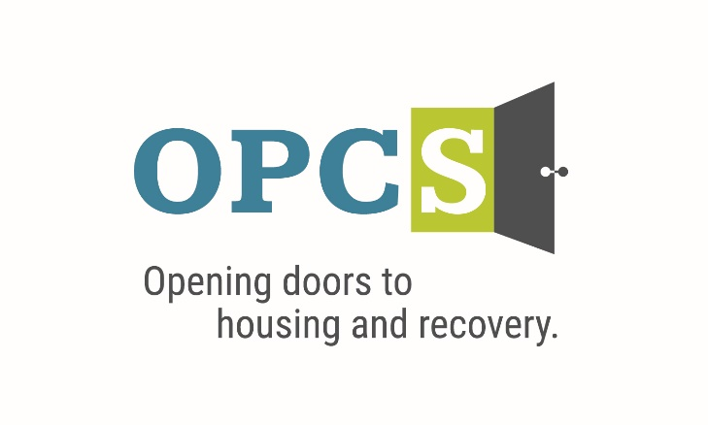

***Southern Arizona’s Premier Social Service Agency***

Old Pueblo Community Services is an EOE/M/F/VET/DISABILITY Employer

|  |  |  |  |  |  |  |  |
| --- | --- | --- | --- | --- | --- | --- | --- |
| **Case Manager**  Re-Entry  Monday-Friday 8:00am – 5:00pm    Responsible for the engagement, needs assessment, support, and coordination of care for individuals served by OPCS. The Case Manager position is expected to service clients that are residing in OPCS’ Re-Entry Housing Programs: RCBM program serving individuals that have recently released from prison that are required to participate in substance use treatment with OPCS, the Set for Success Program serving individuals releasing from incarceration on Community Supervision and that have an SMI determination, and client releasing directly from incarceration. This position requires flexibility, time management and willingness to assist in other programs with OPCS as needed.  **Employee Benefits**  Competitive Salary, Employer Subsidized Health Insurance for Employee ***and Family***, Employer Matching 401 (k) plan (after 1 year), Employer Subsidized Dental Plan and Vision Plan, Paid Life Insurance, Employer Paid Training, 136 Hours Paid Time Off (PTO) Per Year.  ***Selected by the Tucson Metro Chamber of Commerce as the best non-profit for Workforce Development in 2019, and Outstanding Non-profit in 2014.***  **Duties and Responsibilities:**  1. Complete Intake process, Behavioral Health Assessment, and develop case plan in conjunction with each new client. Follow up with weekly case plan reviews to assist client in reaching identified goals.  2. Facilitate weekly life skills and/or substance use group sessions.  3. Maintain all resident files in a confidential manner and in compliance with HUD and HIPAA standards,  4. Interview clients to define level of need: personal and family reunification, finances, employment, food, clothing, housing, medical, mental health, legal and substance abuse issues to determine nature and degree pf problem.  5. Refer clients to mainstream services and other services organizations as needed.  6. Assists clients with applying for and accessing entitled benefits covered under AHCCCS.  7. Provides hands-on support assisting clients with engaging in AHCCS services-i.e., transporting, and accompanying clients to medical and/or behavioral health appointments.  8. Monitor residents’ compliance with program guidelines and provide appropriate guidance to those residents who are out of compliance.  9. Attend Old Pueblo Community Services weekly staff meetings and meet with Supervisory staff as required.  10.Attend all required trainings.  11.Work closely with OPCS team, collaborators, and other members of individuals support team, including Home Health Care agencies, parole, and probation offices.  12.Write letters to courts and other agencies for individuals, as needed.  13.Complete monthly reporting documents for assigned contacts.  14.Other tasks as assigned.  **Qualifications:**  Master’s or Bachelor’s degree in a field related and no related experience OR; Associates’ degree in a related field and 6 months related experience OR; Certified Peer Support Specialist and 1-year year related experience OR; High School diploma or General Education Equivalent (GED) and 2 years related experience. Working knowledge of evidence-based interventions for persons with a variety of behavioral health concerns, including serious mental illness and substance abuse/dependence. Willingness to work with individuals that are required to register as a sex offender. Previous experience of working with this population is a plus.  Willingness to learn and practice evidence-based practices, such as Motivational Interviewing, Housing First and Harm Reduction. Self-starter committed to a team approach, responsible, dependable, ability to set priorities, meet deadlines and work flexible hours. Experience working in racially, ethnically, and socio-economically diverse urban communities. Strong communication, administrative and interpersonal skills. Strong computer skills-Advanced Microsoft Office skills required (Word, Outlook, Excel, and PowerPoint). Experience maintaining client records in Electronic Health Record. Possess and maintain valid CPR/First Aid Certification. Valid Arizona driver’s license, proof of auto insurance and reliable transportation. Bilingual, Bicultural and/or Veteran a plus. |  | |  | | --- | | Job Status Full Time | |  | | Pay Rate $18.88 -$23.10 | | Pay Comments Salary based on experience.  ***We are willing to train those who are passionate about helping people and willing to go the extra mile to help the client.*** |   Mail Resume/Application to:   |  | | --- | | Ms. Jeanie Pike  HR Director  Old Pueblo Community Services  4501 E. 5th St.  Tucson, AZ 85711 |   Email Resume/Application to:  **hr@helptucson.org**  http://bantheboxcampaign.org/wp-content/uploads/2013/01/ban-the-box.jpg  Employment References, drug screen and background check is conducted pre-employment. |