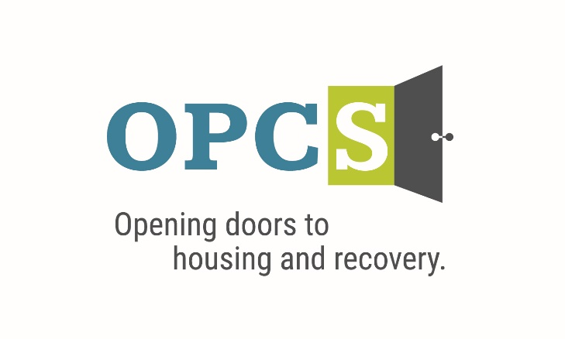

***Southern Arizona’s Premier Social Service Agency***

Old Pueblo Community Services is an EOE/M/F/VET/DISABILITY Employer

|  |  |  |  |  |  |  |  |
| --- | --- | --- | --- | --- | --- | --- | --- |
| **Training Developer**  Monday-Friday 8am-5pm  *Pilot Training Academy*  The Training Developer is responsible for supporting the training and development activities of OPCS’s Training Academy. The training developer will support all aspects of the development continuum including identifying training needs; developing and managing content; measuring competencies; maintaining training records; and facilitating training.  **Employee Benefits**  Competitive Salary, Employer Subsidized Health Insurance for Employee ***and Family***, Employer Matching 401 (k) plan (after 1 year), Employer Subsidized Dental Plan and Vision Plan, Paid life insurance, Employer Paid Training, 136 Hours Paid Time Off (PTO) Per Year.  ***Selected by the Tucson Metro Chamber of Commerce as the best non-profit for Workforce Development in 2019, and Outstanding Non-profit in 2014.***  **Duties and Responsibilities:**   1. Liaise with staff throughout the organization to create multimedia, competency-based training content for OPCS staff. 2. Lead train-the-trainer sessions to equip others to effectively deliver training. 3. Deliver training when needed. 4. Create and facilitate competency assessments. 5. Identify and update training materials as organizational and compliance requirements change. 6. Help maintain training records. 7. Use Learning Management System for training content management. 8. Identify and implement training and development opportunities. 9. Maintain and apply training and development trends and technology. 10. Other duties as assigned.   **Preferred Qualifications**  Bachelor’s degree in social services, business, education, or related behavioral health field. Experience working with culturally diverse, LGBTQ+ and criminal justice involved populations. Experience and knowledge of evidenced-based approaches, Harm Reduction, Trauma Informed Care, and Motivational Interviewing.  **Qualifications:**  Four years related experience in either education/training and/or behavioral health. Knowledge of Adult Learning Theory. Experience with creating multimedia training. Outstanding written and oral communication skills. Strong administrative and interpersonal skills. Strong computer skills, including experience with MS Word, Power Point, and Excel. Ability and willingness to work a flexible schedule when necessary. |  | |  | | --- | | Job Status Full Time | |  | | Pay Rate $18.88 - $23.10 | | Pay Comments Salary based on experience.  ***We are willing to train those who are passionate about helping people and willing to go the extra mile to help the client.*** |   Mail Resume/Application to:   |  | | --- | | Ms. Jeanie Pike  HR Director  Old Pueblo Community Services  4501 E. 5th St.  Tucson, AZ 85711 |   Email Resume/Application to:  **hr@helptucson.org**  http://bantheboxcampaign.org/wp-content/uploads/2013/01/ban-the-box.jpg  Employment References, drug screen and background check is conducted pre-employment. |